Mrs. Morgan’s  Student  News |  | 

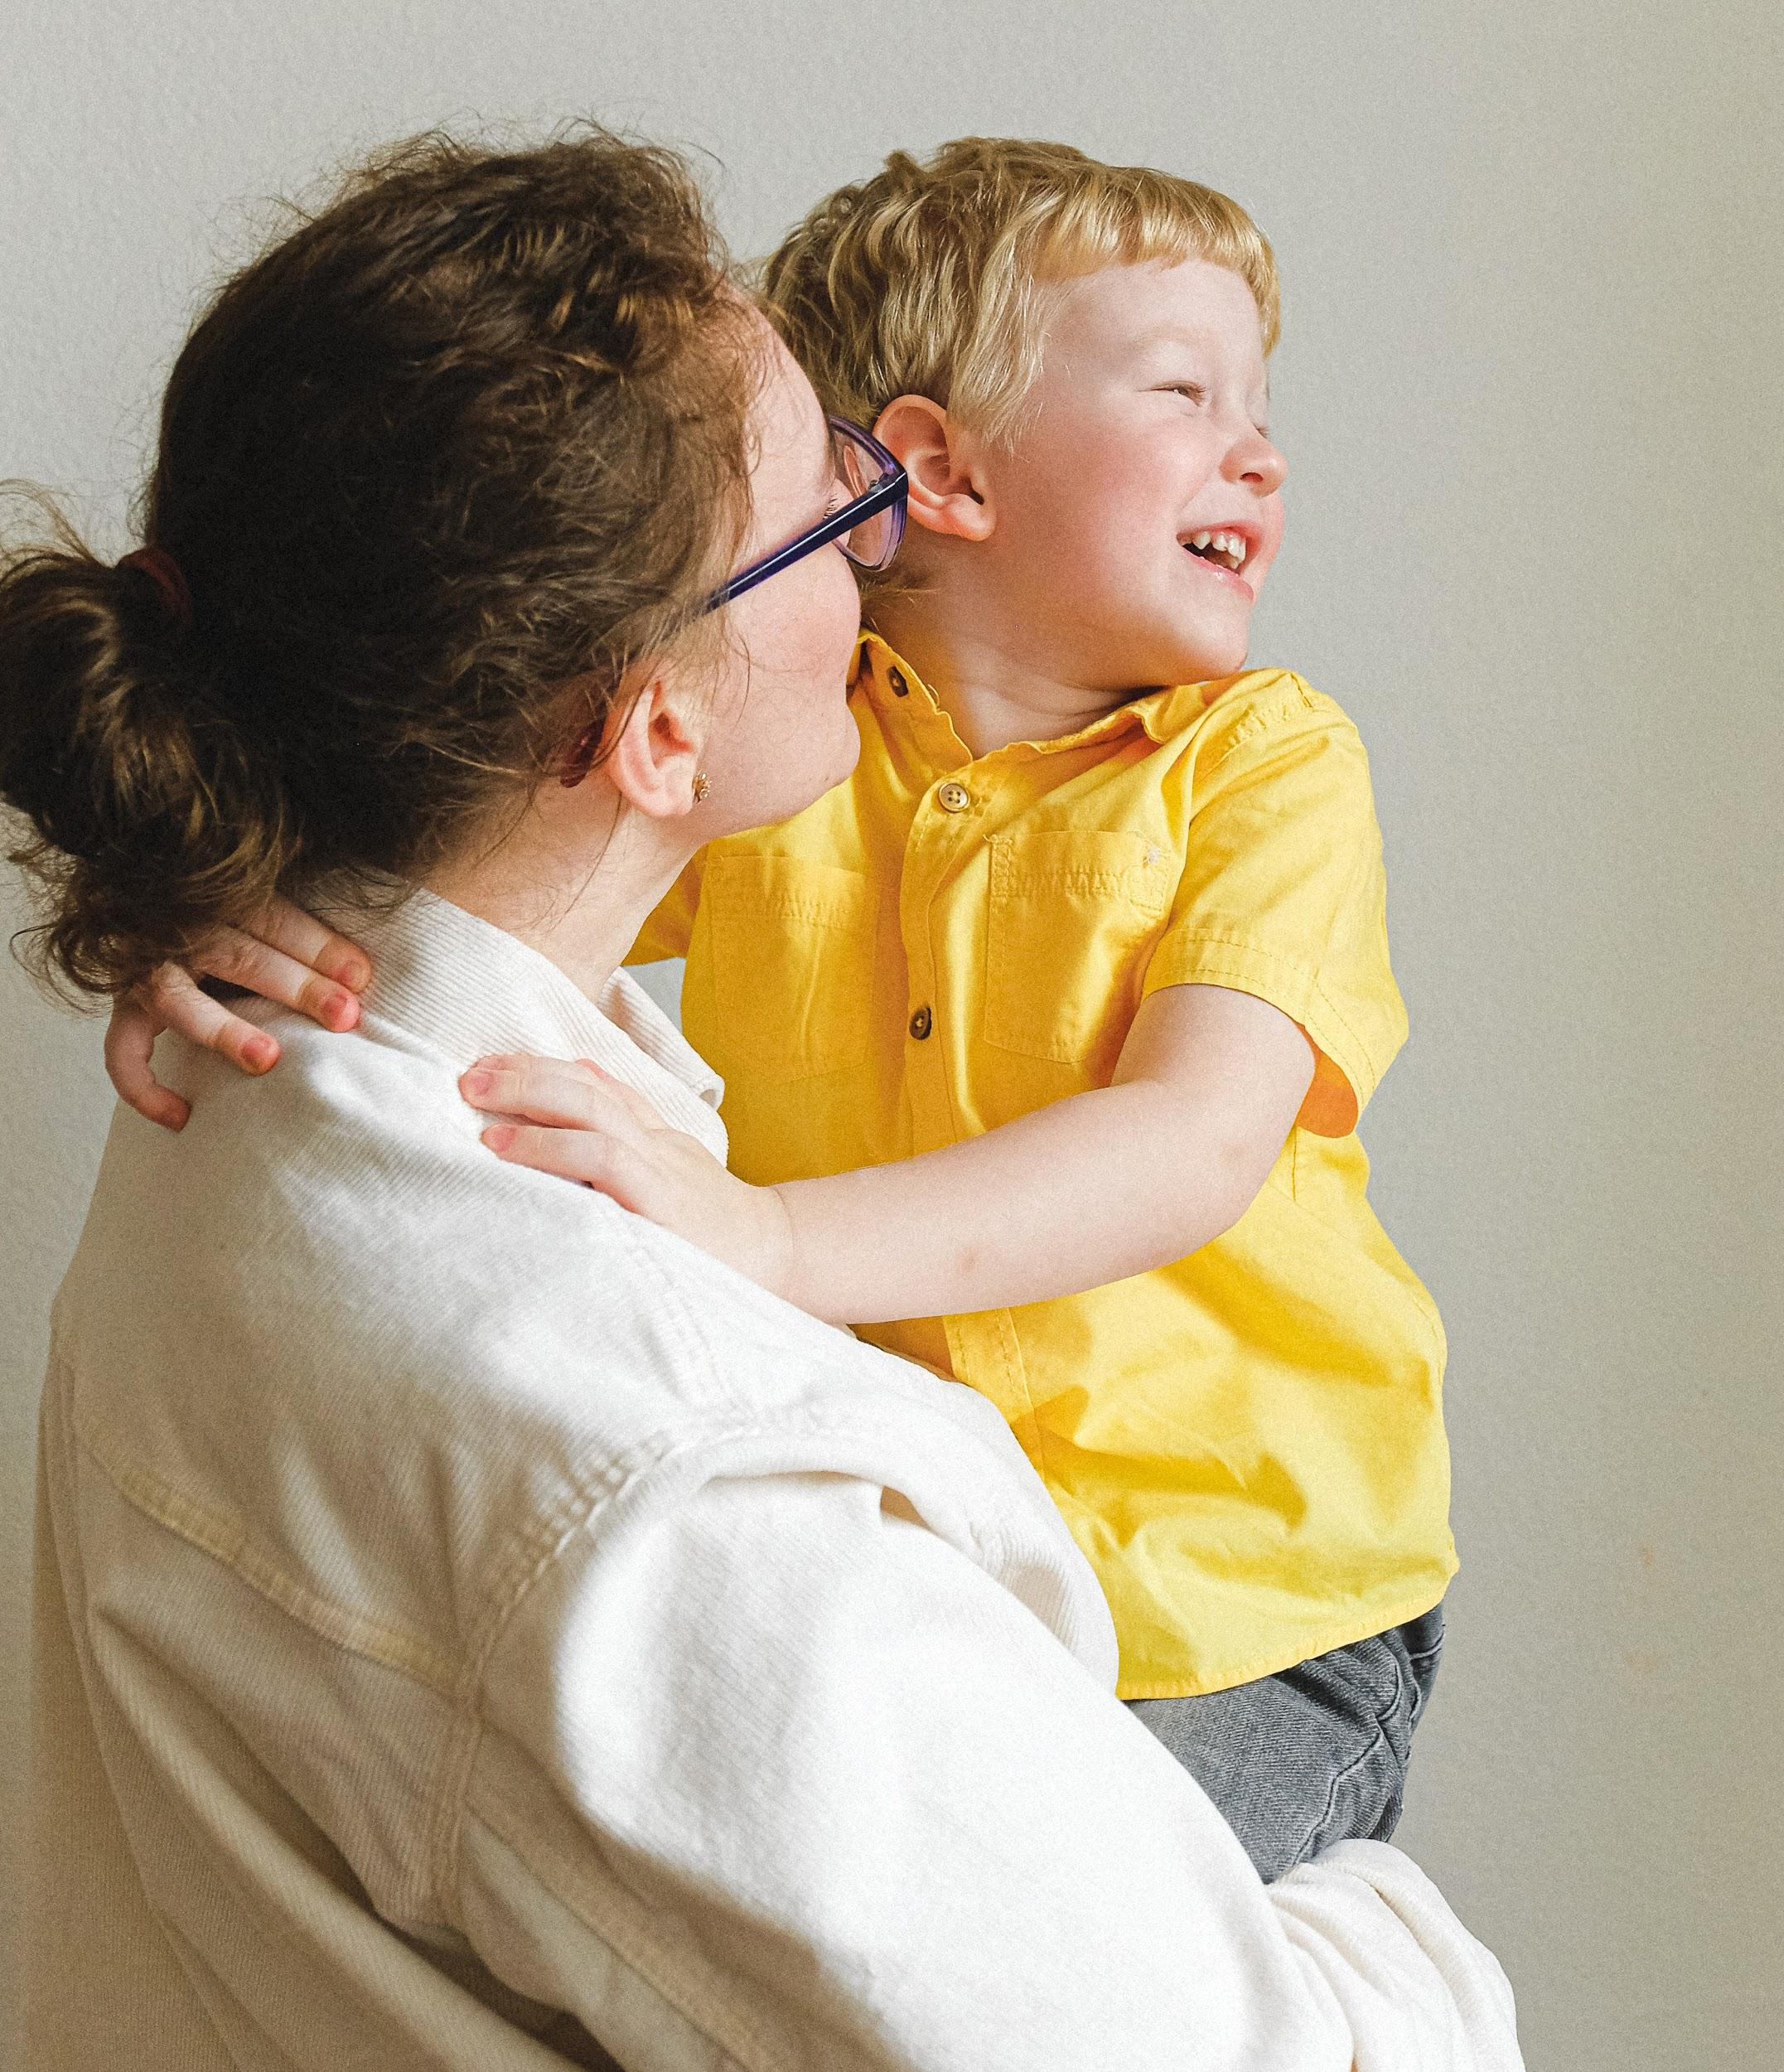 | News for the week of: January 12, 2026  Reading: 20 minutes per night  Multiplication facts: practice 5 minutes each night  Spelling words (learn, dirty, worn, sore, thirst, burn, record, cure, board, course, worth, early, return, pure, world, search, worse, thirteen, sport, current)  Vocabulary:( preferred, captured, injustice, segregation, encounters, nourishing, numerous, example, dream, recall, nourishing)  y
WI
 | Content Standards for the Week:  READING: My Brother Martin  (SKILLS): Figurative Language (Onomatopoeia)  MATH: Fractions/Decimals (tenths, hundredths)
 | Other Communication:  January  (12) WISS $2 spirit wear/$5 “free” dress  (16) Field Trip to Aviation Museum (we currently only have three drivers for 12 students, if we do not have enough drivers we will not go)  (19) No School  (23) Virtue Awards  (26-30) Catholic School’s Week

